 | 

AMMAN ARAB UNIVERSITY
جامعة عمان العربـيــــــة
College of Information Technology
كلية تكنولوجيا المعلومات
قسم هندسة البرمجيات

مشروع مادة تحليل وتصميم النظم
Electronic hotel reservation system
Students

نور ذياب عمر شرباتي | 202320137
رنيم وضاح محمود طومار | 202320248
ملك حسام محمد ناجي الشلبي | 202320321
مروى احمد محيميد النعيمات | 202320991
Supervisor: Dr. Marwan Alsed
A project report submitted in partial fulfillment of the requirements
for Systems Analysis and Design
Amman - Jordan
2024/2025

Abstract
The Electronic Hotel Reservation System is a comprehensive platform designed to streamline hotel operations and enhance the guest experience through automation and real-time management. This system addresses key challenges in traditional hotel management, such as booking delays, manual errors, and inefficient coordination between departments, by providing an integrated solution for reservations, room status updates, invoicing, and performance monitoring.
Key features of the system include:
Role-based access for guests, front desk staff, housekeeping, finance personnel, and hotel managers.
Real-time room availability and booking management, allowing guests to search, reserve, modify, or cancel reservations online.
Automated invoicing with support for charges, discounts, and payment tracking
Smart device integration, including digital door locks and automated notifications for guests and staff.
Performance dashboards for managers to monitor occupancy rates, revenue, and customer satisfaction metrics.
Developed using modern Agile methodologies, the system prioritizes usability, scalability, and security, ensuring compliance with industry standards. It leverages UML diagrams (use cases, activity diagrams, sequence diagrams, and class diagrams) to model interactions, workflows, and system architecture, providing a clear blueprint for implementation.
By centralizing operations and reducing manual intervention, this system improves efficiency, reduces errors, and elevates guest satisfaction, positioning the hotel competitively in the digital hospitality market.
Key Contributions
Automation: Eliminates manual processes in reservations, check-ins, and invoicing.
Integration: Connects with smart devices for seamless guest experiences (e.g., keyless entry).
Analytics: Empowers management with data-driven decision-making tools.
User-Centric Design: Intuitive interfaces for both guests and staff.
This project demonstrates the application of systems analysis and design principles to solve real-world hospitality challenges, ensuring reliability, maintainability, and future scalability.
Keywords: Hotel reservation system, UML modeling, Agile development, smart hospitality, automation.

Table of Contents
Abstract II
THE SYSTEM 1
1.1 Overview 2
1.2 System Description (Overview, Problem, Objectives) 2
Overview: Electronic Hotel Reservation System 2
1.3 Functional Requirements 3
1.4 Non-Functional Requirements 4
1.5 Stakeholders: 5
SYSTEM ANALYSIS 6
2.1 Overview 7
2.2 Use Case Modelling 8
2.2.1 Actors and Uses Cases 8
2.2.2 Use Case Diagram 11
2.2.3 Use Case Description 12
2.3 Domain Class Modeling 18
2.3.1 Classes, Attributes, and Associations 18
2.3.2 Domain Class Diagram 18
SYSTEM DESIGN 19
3.1 Overview 20
3.2 Activity Diagrams 21
3.3 System Sequence Diagrams 26
3.2 Design Class Diagram 31

List of Tables:

Table 1: Manage Reservations use case description 12
Table 2:Update Room Status use case description 13
Table 3: Cancel Reservation use case description 14
Table 4: Monitor Hotel Performance use case description 16
Table 5: Manage Invoices use case description 17
No table of figures entries found.

List of figures:

Figure 1:Guest use cases 8
Figure 2: Receptionist use cases 9
Figure 3: Room service staff 9
Figure 4: Hotel manger 10
Figure 5: Accountant use cases 10
Figure 6: Use case diagram 11
Figure 7: Domain Class Diagram 18
Figure 8: Activity Diagrams(Manage Invoices use case) 21
Figure 9:Activity Diagram Update Room Status 22
Figure 10:Activity Diagram Cancel Reservation. 23
Figure 11 24
Figure 12 26
Figure 13 26
Figure 14: Sequence Diagrams 26
Figure 15 28
Figure 16 29
Figure 17 30
Figure 18: Class Diagram 31

CHAPTER 1

THE SYSTEM

1.1 Overview
Systems analysis and design are essential for developing information systems that meet business needs. The process begins with understanding what the system should do, followed by designing how it will be built. Information systems differ from software applications in that they combine software, data, and procedures. The System Development Life Cycle (SDLC) is used as a structured approach that includes phases from problem identification to maintenance. Modern methods like Agile (a flexible development approach focused on interaction and adapting to changes) and Iterative Development (building the system in small, repeated stages) help improve system quality and accelerate delivery.

1.2 System Description (Overview, Problem, Objectives)

Overview: Electronic Hotel Reservation System
In today’s hospitality landscape, excellence in guest service goes beyond luxurious amenities—it hinges on efficiency, speed, and precision in managing the entire booking experience, from initial reservation to room access. The Comprehensive Electronic Hotel Reservation System is a smart, integrated platform designed to elevate the guest experience while streamlining the responsibilities of hotel staff and management.
This system serves not only guests but also provides dedicated tools and interfaces tailored to the specific roles of: Guests, Front desk staff, Housekeeping and room services, Hotel management, Finance and accounting department.
Each user has a dedicated interface with defined access levels and task-specific features.
The system enables instant online booking with real-time room availability, service comparisons, secure online payments, and immediate delivery of a digital room access code—eliminating the need for manual check-in. Guests can later modify their room code and request early room preparation or luggage handling prior to arrival.
On the other hand, the system enables staff to coordinate tasks efficiently and streamline daily operations. It also supports integration with smart devices such as electronic door locks, alert systems, and instant messaging services, ensuring secure and rapid communication among all departments.
Problem Statement:
Many hotels continue to depend on traditional or fragmented reservation systems, which result in booking delays caused by congestion and poor coordination between departments. Manual data handling leads to errors such as data loss or duplication. Additionally, guest room allocation mistakes frequently occur, including assigning rooms that are already occupied or not yet prepared. Guests often face frustrating waiting times after long journeys due to the lack of real-time information on room availability and status.
Furthermore, the lack of integration with modern payment solutions and smart door lock technology makes room access fully reliant on front desk personnel. This reliance proves impractical during peak hours or late-night arrivals.
These limitations not only diminish guest satisfaction but also erode the hotel’s competitive edge in an increasingly automated and digital hospitality market.
Objectives:
Guest data, room status, and all operational processes are managed through a unified platform that enhances efficiency. The guest experience is elevated through automated notifications, pre-arrival luggage handling, and room preparation, with special attention given to personalized requests and notes to ensure timely and accurate service. Management benefits from comprehensive analytical reports and seamless integration with smart devices such as digital locks and instant request systems—supporting a modern and advanced hotel environment.

1.3 Functional Requirements

1. User Registration and Login
- Ability for users to create accounts with role-based access (guest, staff, admin) and secure login.

2. Room Search
- Guests can search for rooms by check-in date, number of nights, room type, and price, with real-time availability display.

3. Room Booking
- Selection and reservation of rooms by entering guest details.

4. Online Payment
- Secure electronic payment using multiple supported methods (cards, e-wallets, etc.).

5. Booking Management
- Guests can view, modify, or cancel their reservations.
- A digital room access code is sent automatically, which the guest can later customize.

6. Smart Device Integration
- Integration with smart door locks to allow keyless entry without manual check-in.
- Option to request early room preparation or luggage handling before arrival.

7. Room and Availability Management (Staff Use)
- Front desk staff can update room details, adjust pricing, and manage availability in real time.

8. Housekeeping Task Management
- Housekeeping staff can view task schedules based on room status and check-in/check-out times.

9. Reports and Analytics
- Generation of detailed reports on bookings, revenue, performance, and customer satisfaction for management.

10. Automated Notifications
- Automatic messages for booking confirmation, arrival reminders, and staff task alerts.
11. Handling Special Customer Requests
- The system must record any special requests from guests and notify the relevant staff to ensure they are fulfilled before arrival.

1.4 Non-Functional Requirements
Performance
- The system must respond to user actions within 2 seconds under normal usage conditions, based on the User Experience (UX) Benchmark.
Scalability
- The system should support scaling to accommodate an increased number of users, especially during peak seasons.
Security
- All user data and payment information must be encrypted and securely stored, with compliance to relevant data protection regulations.

Availability
- The system should be available 99.9% of the time, minimizing downtime for maintenance, balancing cost and benefit, and following industry standards.
Usability
- The user interface must be user-friendly and intuitive for both customers and hotel staff.
Maintainability
- The system architecture should support updates, bug fixes, and new feature additions without disrupting ongoing operations.
Compatibility
- The system must be accessible across various devices (desktop, tablet, mobile) and support major web browsers.
Localization
- The system must support multiple languages to meet the needs of users from different regions.

1.5 Stakeholders:
- Guests: The end-users of the system who make room reservations, process payments, and receive digital room access codes.
- Front Desk Staff: Manage daily reservations, assist guests with any issues, and coordinate between departments such as housekeeping and finance.
- Housekeeping and Room Service Department: Responsible for preparing and cleaning rooms and responding to guest requests like room preparation or luggage handling.
- Hotel Manager: Oversees overall hotel performance, reviews daily, weekly, and monthly reports, and ensures continuous service improvement.
- Finance and Accounting Department: Manages guest payments, prepares invoices, and tracks revenue and expenses.

CHAPTER 2

SYSTEM ANALYSIS

2.1 Overview
When developing an information system, it is essential to clearly define its requirements to ensure success. These include functional requirements, which specify what the system must accomplish—referred to as Use Cases—such as inventory management and order processing. In addition, non-functional requirements address the user experience, including interface design and language support. The system must also meet reliability requirements to ensure continuous operation, as well as security requirements to protect data. Performance requirements define the system’s responsiveness and transaction processing capabilities. Other important considerations include compatibility with existing systems, scalability for future growth, and ease of maintenance and updates. The FURPS+ framework—standing for Functionality, Usability, Reliability, Performance, and Security, along with additional categories—helps classify and guide the analysis to ensure the system effectively meets user needs.

2.2 Use Case Modelling

2.2.1 Actors and Uses Cases
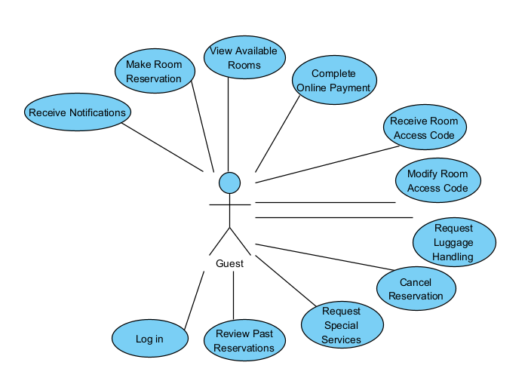
Figure 1:Guest use cases

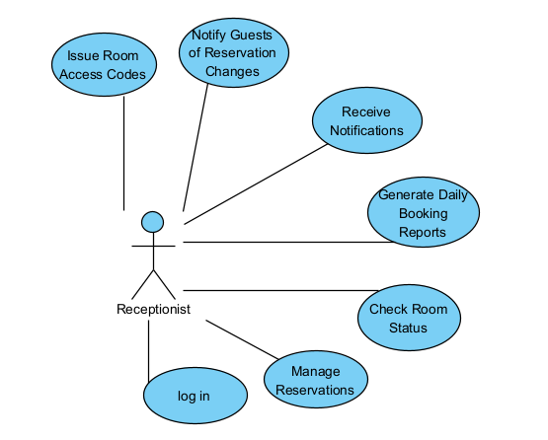
Figure 2: Receptionist use cases
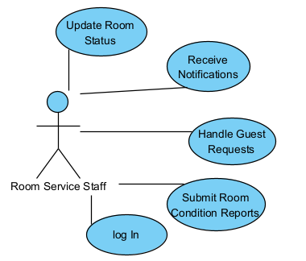
Figure 3: Room service staff

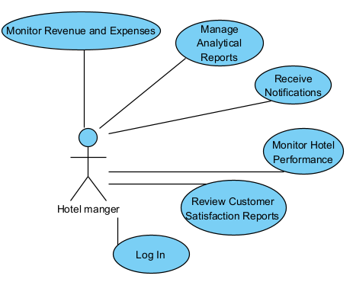
Figure 4: Hotel manger
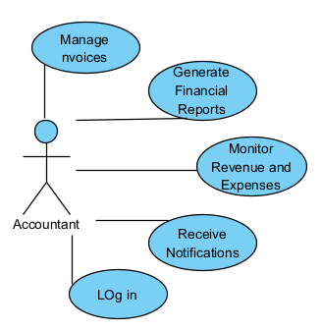
Figure 5: Accountant use cases

2.2.2 Use Case Diagram
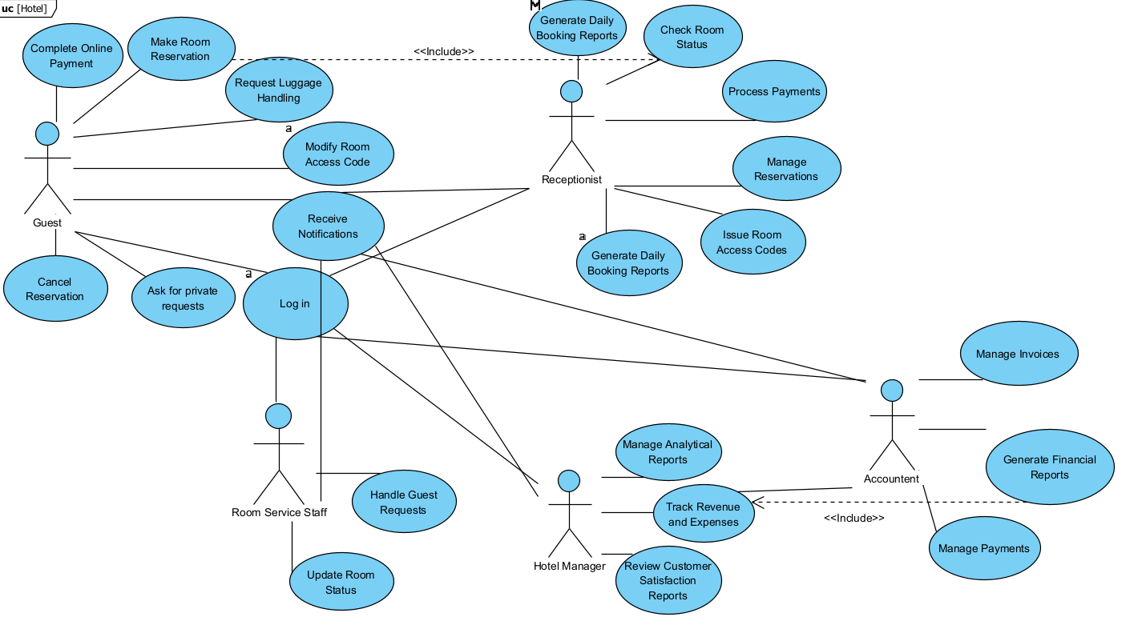
Figure 6: Use case diagram

2.2.3 Use Case Description
Use case name: | Manage Reservations.
Scenario: | The front desk staff wants to view, edit, or cancel a guest’s reservation.
Triggering Event: | Staff logs into the system and selects "Manage Reservations.
Brief Description: | The front desk staff uses the system to access current and upcoming reservations, make changes if needed, or cancel bookings upon request.
Actors: | Front Desk Staff.
Stakeholders: | Hotel Administration, Guest.
Pre-conditions: | Staff is authenticated and logged into the system.
Post-conditions: | Reservation is modified, cancelled, or confirmed as per action.
Flow of event: | Actor System  1. Staff searches for a guest reservation. 2. System displays matching reservation records.  3. Staff selects a reservation to view or modify. 4. System shows full reservation details.  5. Staff makes edits or cancels the reservation. 6. System updates the reservation and logs the change.  7. — 8. System notifies the guest via email or SMS, if applicable.
Exception Conditions: | - If the reservation is not found, the system displays an error message.  - If changes violate booking rules (e.g., cancel too late), the system blocks the action.  - If system connection is lost, action may be rolled back.
Table 1: Manage Reservations use case description

Use case name: | Update Room Status.
Scenario: | Housekeeping staff needs to update the status of a room (e.g., cleaned, out-of-service).
Triggering Event: | Staff logs into the system and selects the room to update.
Brief Description: | Housekeeping uses the system to set the room status (e.g., "cleaned", "needs maintenance", "ready") so that other departments are informed in real time.
Actors: | Housekeeping Staff.
Stakeholders: | Front Desk, Hotel Manager.
Pre-conditions: | Staff is logged in and has access rights.
Post-conditions: | Room status is updated and visible across the system.
Flow of event: | Actor System  1. Staff selects a room from the room list. 2. System displays current status and update options.  3. Staff selects new status (e.g., “Ready”). 4. System saves the new status in real time.  5. — 6. System updates room view for other departments.
Exception Conditions: | - If selected room ID is invalid, system shows an error.  - If staff lacks permission, access is denied.  - If update fails due to system error, changes are not saved.
Table 2:Update Room Status use case description

Use case name: | Cancel Reservation.
Scenario: | The guest decides to cancel a previously made room reservation.
Triggering Event: | Guest logs into the system and selects a reservation to cancel.
Brief Description: | The guest accesses their reservation history, selects a reservation, and submits a cancellation request. The system processes the request, updates the status, and (if applicable) sends a cancellation confirmation.
Actors: | Guest.
Stakeholders: | Guest, Front Desk, Hotel Administration.
Pre-conditions: | Guest is logged in and has an active reservation.
Post-conditions: | Reservation is cancelled and status updated in the system.
Flow of event: | Actor System  1. Guest logs in and navigates to "My Reservations". 2. System displays a list of the guest’s active reservations.  3. Guest selects the reservation to cancel. 4. System displays reservation details and cancellation option.  5. Guest confirms cancellation. 6. System processes the cancellation and updates status.  7. System sends cancellation confirmation to the guest.
Exception Conditions: | - If the reservation is already past the check-in date, cancellation is not allowed.  - If system fails to update the status, an error message is shown.  - If the guest’s session times out, the operation is canceled automatically.
Table 3: Cancel Reservation use case description

Use case name: | Monitor Hotel Performance.
Scenario: | The hotel manager wants to review operational metrics and performance indicators.
Triggering Event: | Manager logs into the system and accesses the performance dashboard.
Brief Description: | The hotel manager uses the system to view key performance data such as occupancy rates, average revenue per room, customer satisfaction metrics, and service response times. These insights help in evaluating business trends and operational efficiency.
Actors: | Hotel Manager.
Stakeholders: | Hotel Management, Owners/Executives.
Pre-conditions: | Manager is authenticated and has admin-level access.
Post-conditions: | Performance data is retrieved and displayed for analysis.
Flow of event: | Actor System  1. Manager logs into the system. 2. System verifies credentials and grants access.  3. Manager opens the performance dashboard. 4. System retrieves latest performance metrics from the database.  5. Manager filters or selects a date range or metric. 6. System updates the dashboard view accordingly.  7. System enables exporting the data (PDF/Excel) if requested. _
Exception Conditions: | - If data is incomplete or corrupted, system notifies user with a warning.  - If the manager’s access is restricted or expired, system denies entry.  - If dashboard fails to load due to a system error, system displays an error message.
Table 4: Monitor Hotel Performance use case description

Use case name: | Manage Invoices.
Scenario: | A finance staff member wants to view, create, or update guest invoices.
Triggering Event: | Staff logs into the system and accesses the invoicing module.
Brief Description: | The finance staff uses the system to generate new invoices for guest stays, update existing invoices (e.g., with extra charges or discounts), and review payment statuses. The system maintains financial accuracy and links invoices to guest records.
Actors: | Finance Staff.
Stakeholders: | Hotel Management, Guests.
Pre-conditions: | Staff is authenticated with access to financial modules.
Post-conditions: | Invoice is generated, updated, or marked as paid/unpaid.
Flow of event: | Actor System  1. Staff logs into the system. 2. System verifies credentials and grants access to invoices.  3. Staff selects a guest or reservation. 4. System displays related invoice(s) or option to create new.  5. Staff adds charges, discounts, or notes. 6. System updates invoice totals and saves changes.  7. System updates invoice status (e.g., unpaid, paid, pending). _
Exception Conditions: | - If the selected reservation has no charges, the system prevents invoice creation.  - If invoice data is incomplete (e.g., missing payment method), system flags an error.  - If staff lacks permission to edit, access is denied with a message.  - If the system fails to save changes, it displays an error and prompts a retry.
Table 5: Manage Invoices use case description

2.3 Domain Class Modeling

2.3.1 Classes, Attributes, and Associations
Element | Description | Examples
Classes | Main system entities representing real-world objects | Customer, Room, Reservation
Attributes | Data elements that describe each class | Customer: name, email, phone  Room: number, type, price
Associations | Connections between classes showing relationships and multiplicity | One Customer can make multiple Reservations (one-to-many relationship)
Table 6 Classes, Attributes, and Associations

2.3.2 Domain Class Diagram
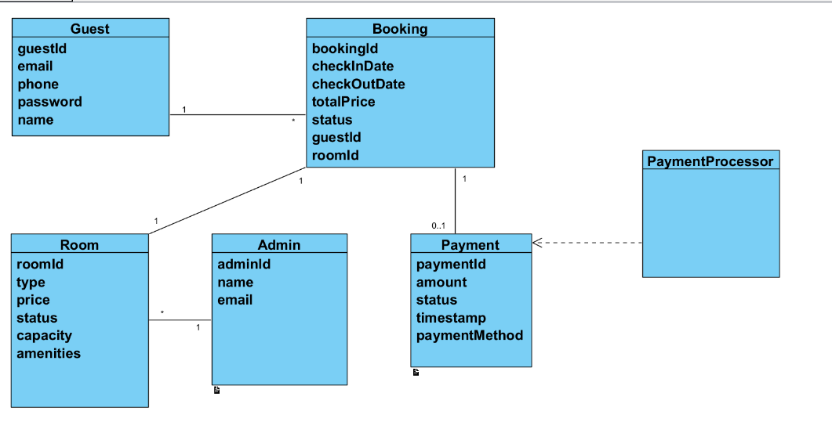
Figure 7: Domain Class Diagram

CHAPTER 3

SYSTEM DESIGN

3.1 Overview
System design requires precise behavioral modeling to ensure that all requirements are effectively addressed. Activity diagrams illustrate the sequence of operations and user interactions with the system, including branching and parallel execution. System sequence diagrams define the exchanged messages that represent inputs and outputs for each use case. CRUD analysis—standing for Create, Read, Update, and Delete—helps verify comprehensive functional coverage by linking domain entities to use cases. The integration of these models provides a solid foundation for a well-structured design that accurately reflects user needs and enhances system reliability and efficiency.

3.2 Activity Diagrams

Front Desk Staff(Manage Reservations.)
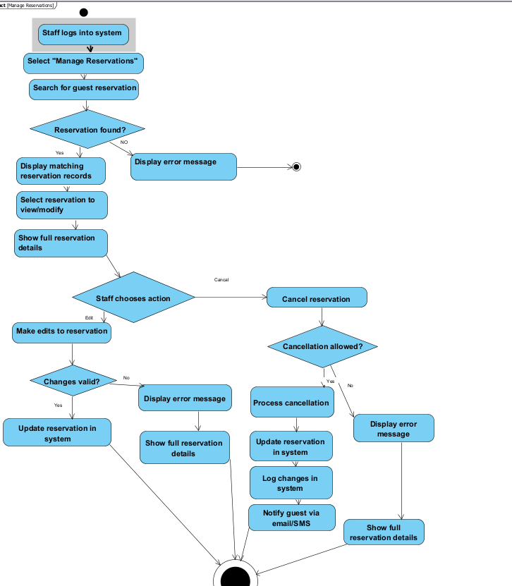
Figure 8: Activity Diagrams(Manage Invoices use case)

Housekeeping Staff.(Update Room Status.)
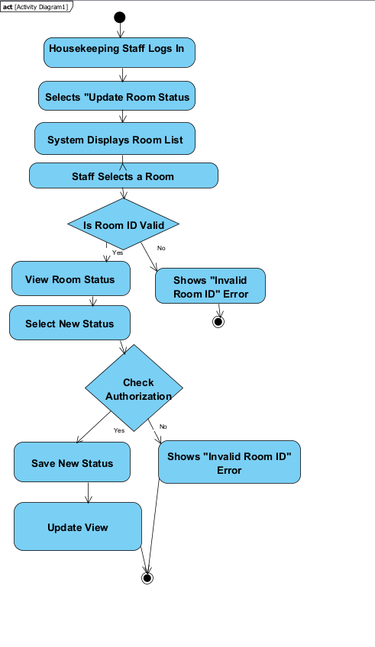
Figure 9:Activity Diagram Update Room Status

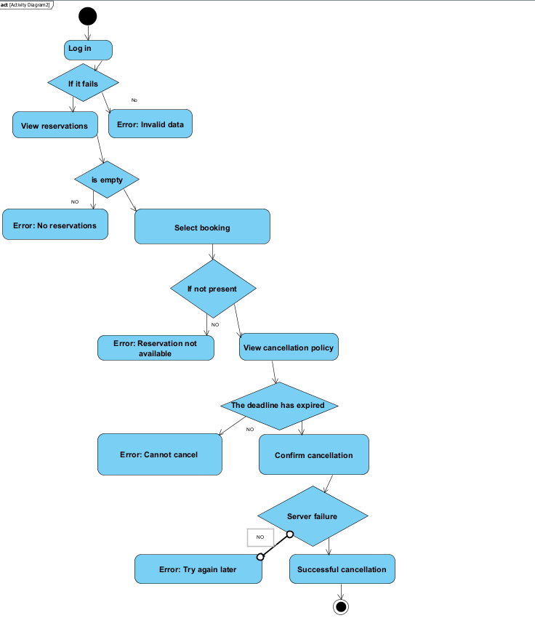
Guest(Cancel Reservation)

Figure 10:Activity Diagram Cancel Reservation.

Hotel Manager(Monitor Hotel Performance.)
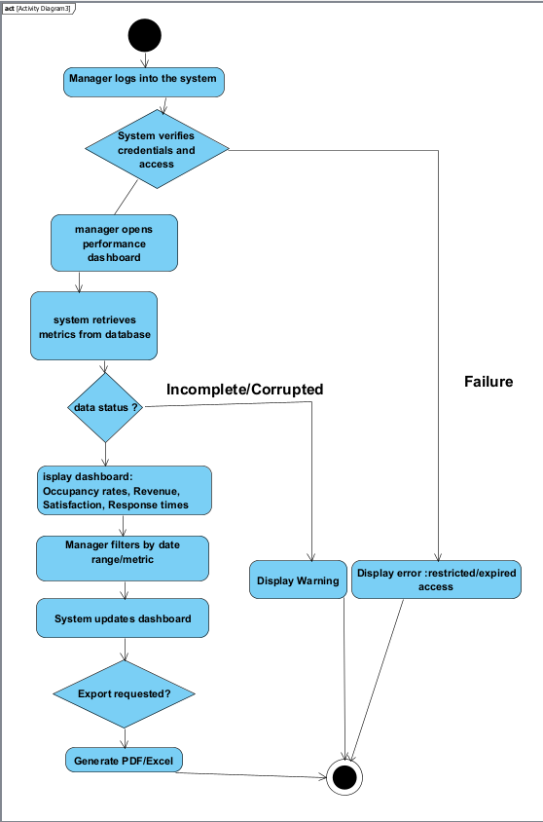
Figure 11 Monitor Hotel Performance

Finance Staff(Manage Invoices.)
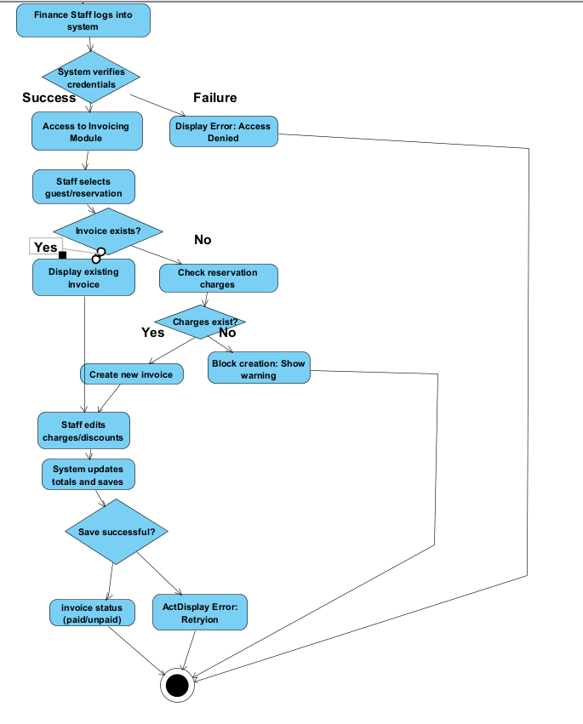
Figure 12(Manage Invoices
Figure 13

3.3 System Sequence Diagrams

Front Desk Staff(Manage Reservations.)
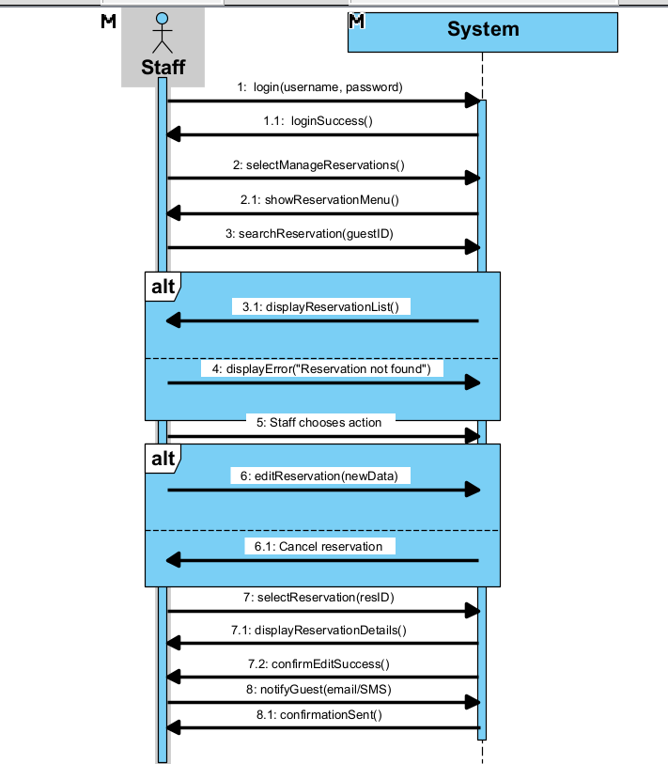
Figure 14: Sequence Diagrams Manage Reservations

Housekeeping Staff.(Update Room Status.)

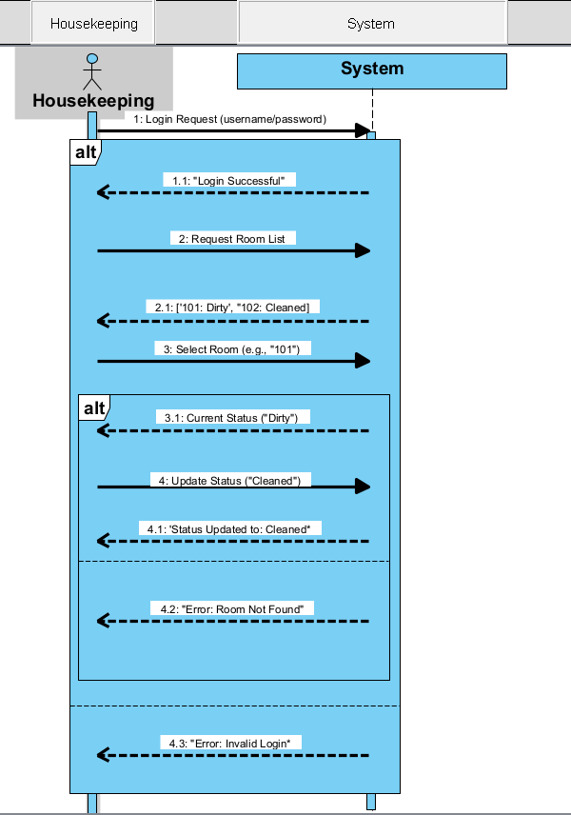
Figure 11: housekeeping Update Room Status

Guest(Cancel Reservation)
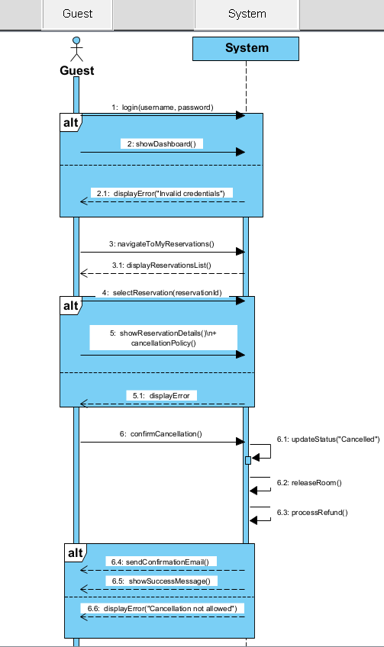
Figure 15 Cancel Reservation

Hotel Manager(Monitor Hotel Performance.)
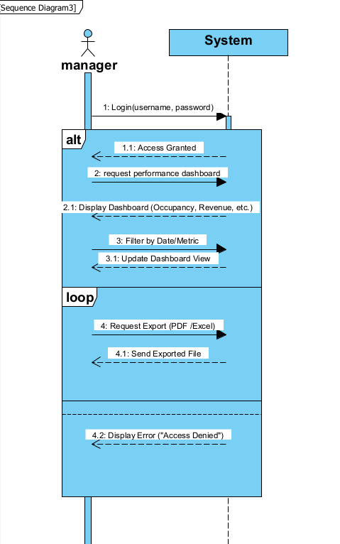
Figure 16 Monitor Hotel Performance

Finance Staff(Manage Invoices.)

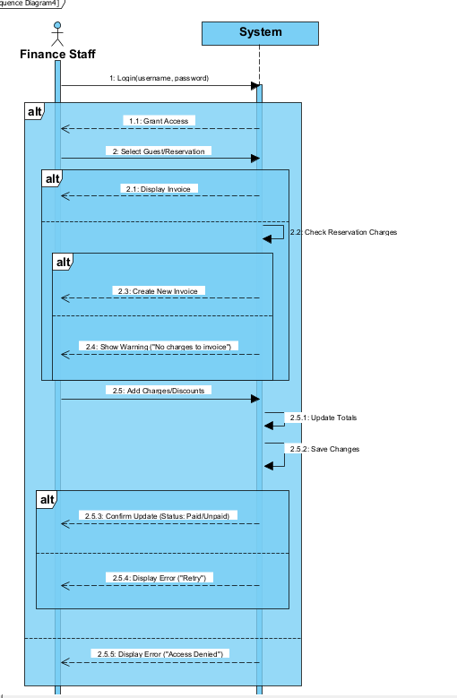
Figure 17(Manage Invoices

3.2 Design Class Diagram

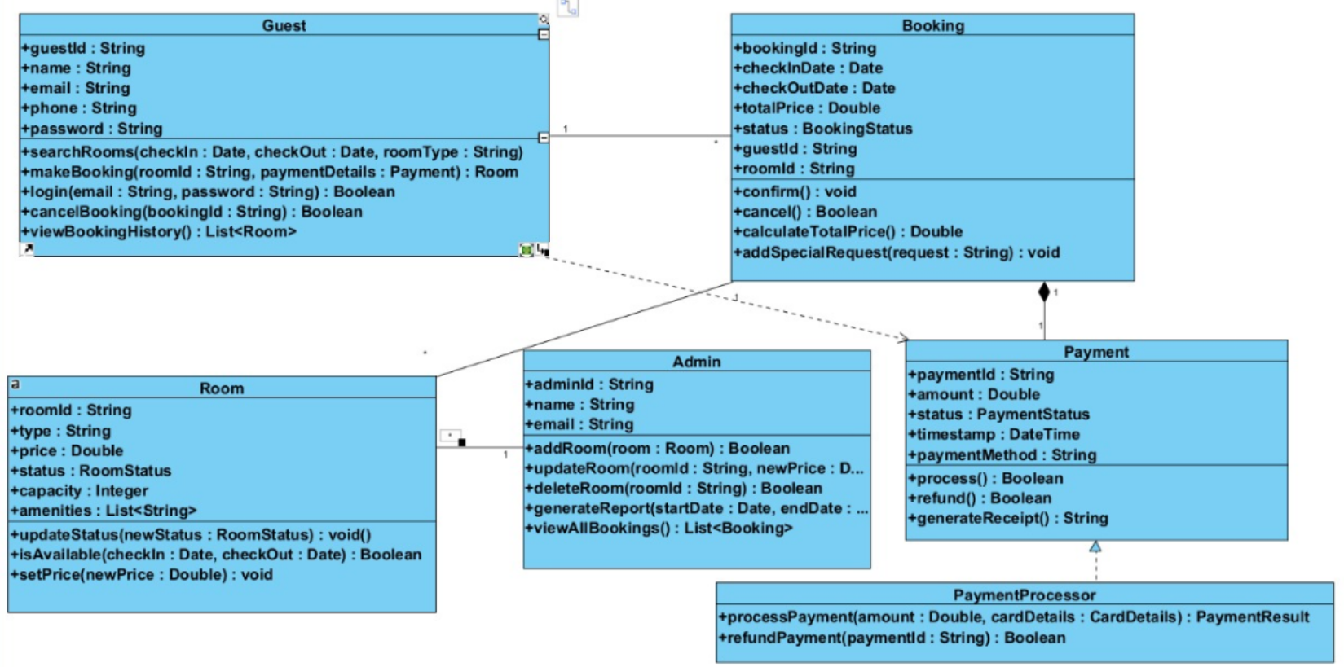
Figure 18: Class Diagram

